Contenido
Background Information 2
Objective: 2
Methodology 3
Who 3
Where 3
When The exact date of data collection is not specified. However, it can be reasonably assumed that the data originates from around the year 2024, based on the timing of the competition in which it was provided. 3
How 3
Data Description 4
Data Exploration 5
Missing Data: 5
Nulls by columns 5
Nulls by user 7
Current situation dataset 8
Sliding Window (ML/Forecasting) – Concept 8
Input 8
Target 8
Time Series 9
Overall 9
Suggest how to manage it? 9

Background Information

Objective:
The purpose of this dataset is to provide comprehensive information on several key health indicators. It includes data on:
- Blood glucose levels
- Insulin levels
- Heart rate readings
- Carbohydrate intake
- Step counts recorded at various times
- Calorie burns during specific periods
- Indicator of blood glucose level in future for train dataset
Overall physical activity levels
Additionally, the dataset aims to support the prediction of future blood glucose trends based on the combined analysis of these variables, the dataset does not specify clearly how to predict the blood glucose indicator, it’s disposed to be used as a source to predict the indicator using the techniques of data analysis

Methodology

Who
The dataset contains information from nine young adults living with type 1 diabetes.

Where
The data was collected in the United Kingdom, although no specific city is mentioned.
When
The exact date of data collection is not specified. However, it can be reasonably assumed that the data originates from around the year 2024, based on the timing of the competition in which it was provided.

How
The dataset was collected as part of the BrisT1D Blood Glucose Prediction Competition, which ran from September to November 2024. It features real-world data from nine young adults in the UK living with type 1 diabetes. Participants wore continuous glucose monitors, used insulin pumps, and were provided with smartwatches to track physical activity. The goal of the study was to gather diverse, time-stamped health metrics to support the development of algorithms that predict blood glucose levels one hour into the future using the previous six hours of data.
This data collection effort aimed to address the complexity of managing type 1 diabetes, where factors presumably like carbohydrates, physical activity in steps and heart rates, and levels of insulin. Although the dataset does not prescribe a specific modeling method, it was designed to encourage data scientists to explore predictive techniques using real-world conditions.

Data Description

train.csv
id - row id consisting of participant number and a count for that participant
p_num - participant number
time - time of day in the format HH:MM:SS
bg-X:XX - blood glucose reading in mmol/L, X:XX(H:MM) time in the past (e.g. bg-2:35, would be the blood glucose reading from 2 hours and 35 minutes before the time value for that row), recorded by the continuous glucose monitor
insulin-X:XX - total insulin dose received in units in the last 5 minutes, X:XX(H:MM) time in the past (e.g. insulin-2:35, would be the total insulin dose received between 2 hours and 40 minutes and 2 hours and 35 minutes before the time value for that row), recorded by the insulin pump
carbs-X:XX - total carbohydrate value consumed in grammes in the last 5 minutes, X:XX(H:MM) time in the past (e.g. carbs-2:35, would be the total carbohydrate value consumed between 2 hours and 40 minutes and 2 hours and 35 minutes before the time value for that row), recorded by the participant
hr-X:XX - mean heart rate in beats per minute in the last 5 minutes, X:XX(H:MM) time in the past (e.g. hr-2:35, would be the mean heart rate between 2 hours and 40 minutes and 2 hours and 35 minutes before the time value for that row), recorded by the smartwatch
steps-X:XX - total steps walked in the last 5 minutes, X:XX(H:MM) time in the past (e.g. steps-2:35, would be the total steps walked between 2 hours and 40 minutes and 2 hours and 35 minutes before the time value for that row), recorded by the smartwatch
cals-X:XX - total calories burnt in the last 5 minutes, X:XX(H:MM) time in the past (e.g. cals-2:35, would be the total calories burned between 2 hours and 40 minutes and 2 hours and 35 minutes before the time value for that row), calculated by the smartwatch
activity-X:XX - self-declared activity performed in the last 5 minutes, X:XX(H:MM) time in the past (e.g. activity-2:35, would show a string name of the activity performed between 2 hours and 40 minutes and 2 hours and 35 minutes before the time value for that row), set on the smartwatch
bg+1:00 - blood glucose reading in mmol/L an hour in the future, this is the value you will be predicting (not provided in test.csv)

Data Exploration

Accuracy
Pending

Missing Data:

Nulls by columns

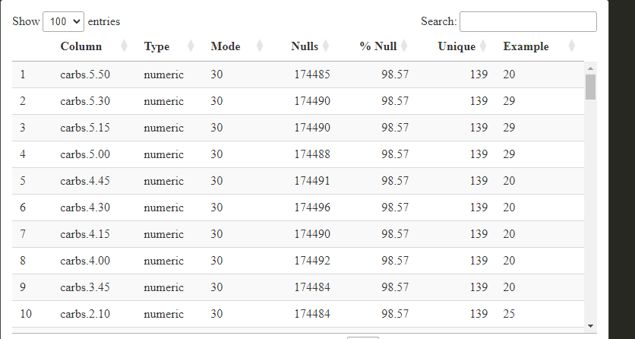
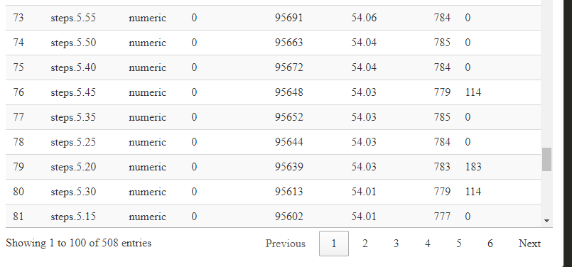
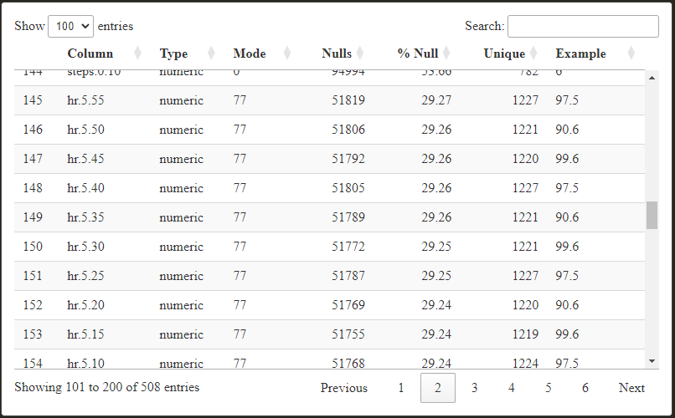
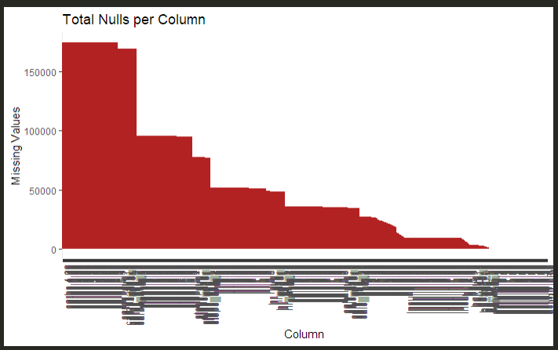
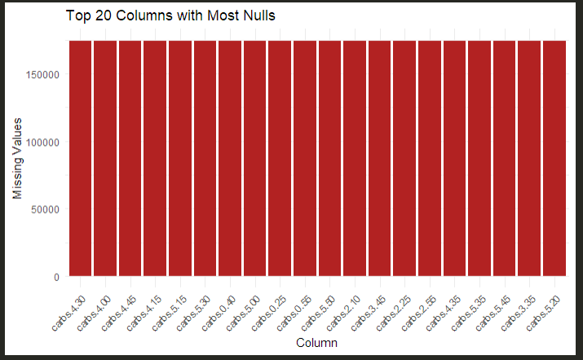

Nulls by user
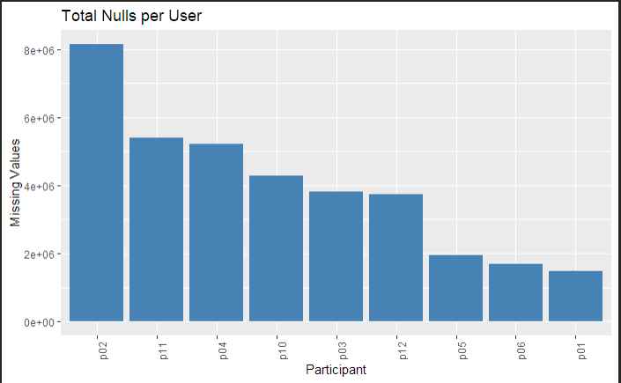

Current situation dataset

Sliding Window (ML/Forecasting) – Concept
A sliding window is a method used in time series or forecasting tasks where a fixed number of past data points (rows) are taken as input to predict a future value.
- Window length: Number of past rows to use (e.g., 4 rows = 1 hour).
- Stride: How far the window moves forward each time (e.g., 1 row = 15 mins).
- Columns each 72 columns represent 1h

Input
Combined values of blood glucose, insulin, and meals over the window.

Target
Future blood glucose value (e.g., in 15 or 60 minutes).

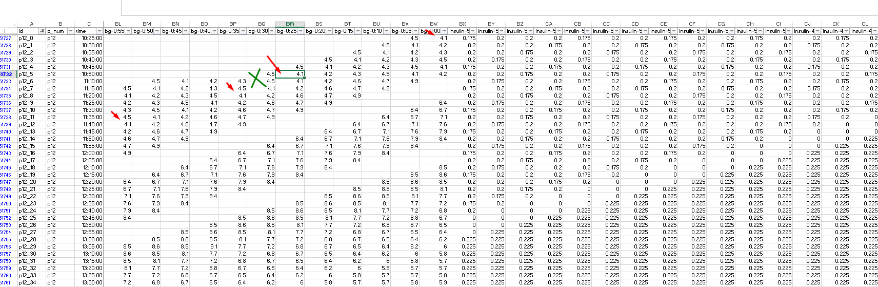

Time Series
A time series is a sequence of data points collected or recorded over time at regular intervals (e.g., every 5 minutes, daily, monthly).
In this scenario we have on columns a row in different distributions

Overall
The majority of the dataset consists of numeric variables representing measured values (e.g., blood glucose levels, insulin doses, or meal counts). These variables are continuous or discrete and are suitable for statistical analysis and modeling.

Suggest how to manage it?

